UNIT 4: Linear Transformation, Eigen Values and Vectors

Tutorial 1

- Find eigenvalues and eigenvectors of 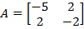
[Ans. -1,-6 and 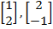]
- Find eigenvalues and eigenvectors of 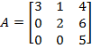
[Ans. 2,3,5 and 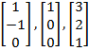]
- Find eigenvalues and eigenvectors of 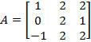
[Ans. 1,2,2 and 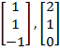]
- Find eigenvalues and eigenvectors of 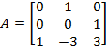
[Ans. 1,1,1 and ]
- Find eigenvalues and eigenvectors of 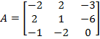
[Ans. 5,-3,-3 and 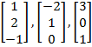]
- Find eigenvalues and eigenvectors of 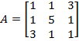
[Ans. -2,3,6 and 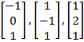]
- Find eigenvalues and eigenvectors of 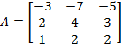
[Ans. 1,1,1 and 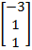]
- Find eigenvalues and eigenvectors of 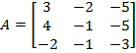
[Ans. 5,2,2 and 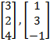]
- If 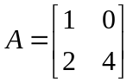then find eigen values of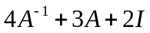. [Ans. 9, 15]
- If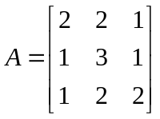 then find eigen values and eigen vectors of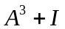.
[Ans: 2, 2, 126 and 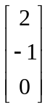, 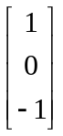 , 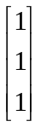 ]
- If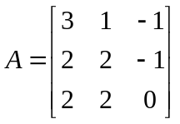 then find eigen values and eigen vectors of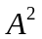.
[Ans: 2, 4, 4 and 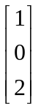, 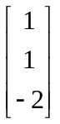]
- If the product of two eigen values of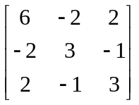 is 16, find the third eigen value. [Ans. 2]

- Determine the algebraic multiplicity and geometric multiplicity for 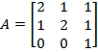.
[Ans. For , A.M.=2 & G.M.=2; For , A.M.=1 & G.M.=1]
- Find Eigenvalues and eigenvectors for following Symmetric matrix
a. 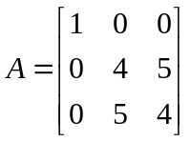 [Ans. 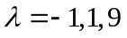 and 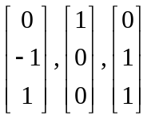 ]
b. 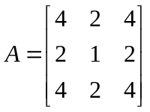 [Ans. 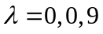 and 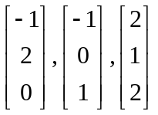 ]
c. 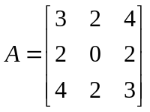 [Ans. 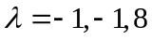 and ]
- Show that for given skew symmetric matrix 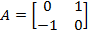, the eigenvalues are purely imaginary.
- Find eigenvalues of the skew symmetric matrix, 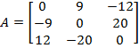.
[Ans. ]
- Find eigenvalues of the orthogonal matrix, 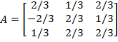
[Ans. 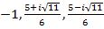 ]
- Find Eigen values and Eigen vectors for the following matrices:
a. 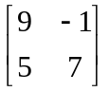 [Ans. 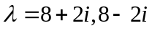 and 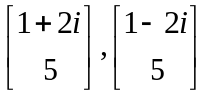]
b. 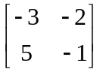 [Ans. 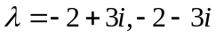 and 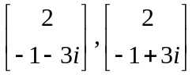]
c. 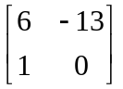 [Ans. 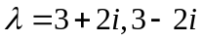 and 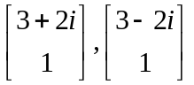]
d. 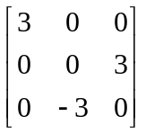 [Ans. 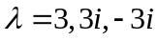 and 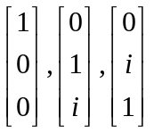 ]

- Find Eigen values and Eigen vectors for the following orthogonal matrix
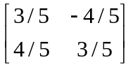 [Ans. 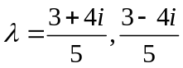 and 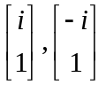 ]
Tutorial No.2
Based on Diagonalization of Matrices & Cayley-Hamilton Theorem

- Show that the matrix 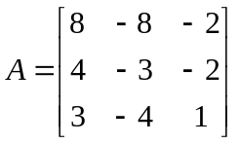 is diagonalisable. Find the transforming matrix and the diagonal matrix.
[Ans. 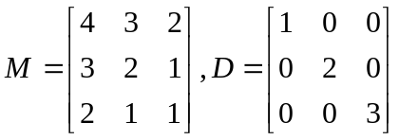]
- Show that the matrix 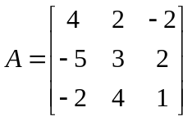 is diagonalisable. Find the transforming matrix and the diagonal matrix.
[Ans. 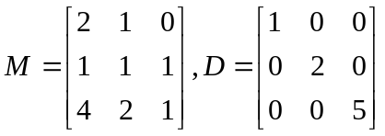]
- Show that the matrix 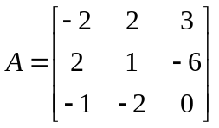 is diagonalisable. Find the transforming matrix and the diagonal matrix.
[Ans. 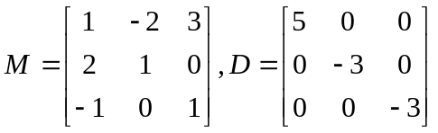]
- Show that the matrix 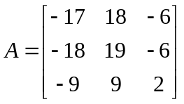 is diagonalisable. Find the transforming matrix and the diagonal matrix.
[Ans. 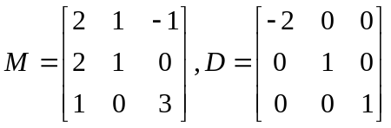]
- Show that the matrix 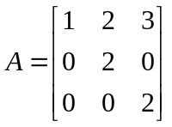 is not similar to a diagonal matrix.
- Show that the matrix 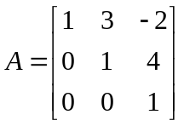 is not similar to a diagonal matrix.
- Apply Cayley-Hamilton theorem to 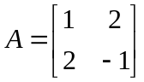 and deduce that 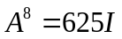
- If 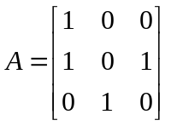 , show that for every integer 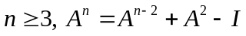 , hence find 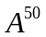. [Ans. 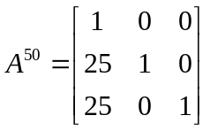]
Apply Cayley-Hamilton theorem to the following matrices and obtain the inverse
- 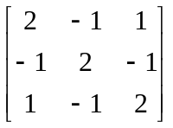 [Ans. 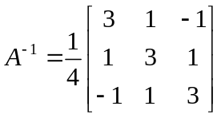]
- 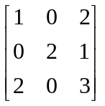 [Ans. 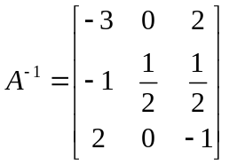]
- 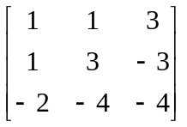 [Ans. 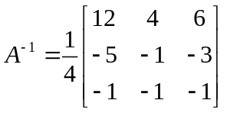]
- 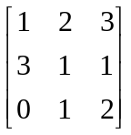 [Ans. 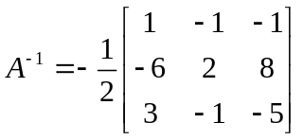]
Find the characteristic equation of the matrix A and hence find 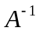 and 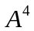.
- 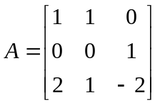 [Ans. 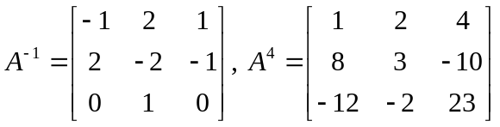]
- 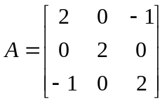 [Ans. 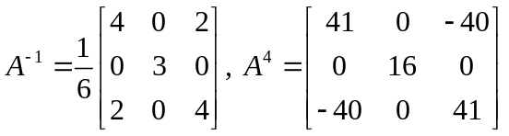]
- 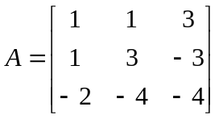 [Ans. 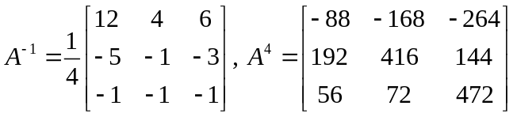]
- Find the characteristic equation of the matrix A given below and hence, find the matrix represented by, where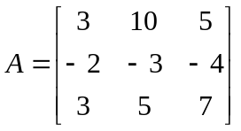 [Ans. 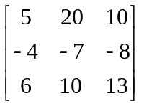 ]

- Find the characteristic equation of the matrix A given below and hence, find the matrix represented by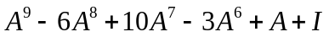, where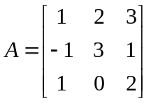.
[Ans. 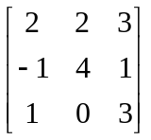 ]

Tutorial 3
Quadratic Forms

- Write down the matrix of the quadratic form
- 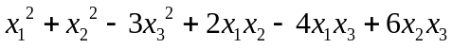
- For the linear transformation 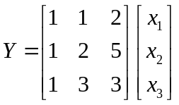 , find the coordinates 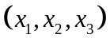 corresponding to (2, 0, 5) in Y Ans (13/5,11/5, -7/5)
- Given the transformation 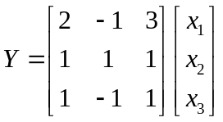 find the coordinates corresponding to (9, 6, 2)in Y. Ans: (1, 2, 3)
- Express each of the following transformations
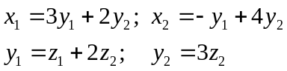 in the matrix form and find the composite transformation which expresses 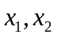 in terms of 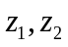.
Ans: 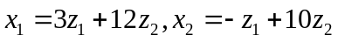
- Express each of the following transformations
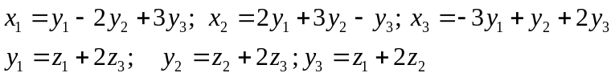 in the matrix form and find the composite transformation which expresses 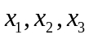 in terms of 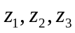.
Ans:
- Obtain the linear transformation of the quadratic form 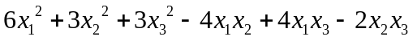 under the linear transformation 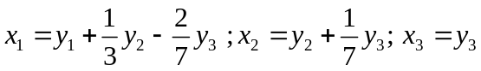and interpret your result
Ans: 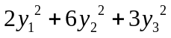
- Reduce the quadratic form to normal form through congruent transformations..
- 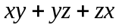 Ans: 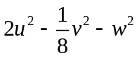,
- 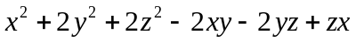 Ans: 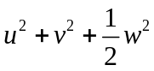
- Reduce the quadratic form 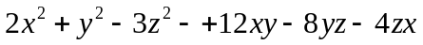 to normal form through congruent transformations. Also find its rank, signature, index and value class. Ans: 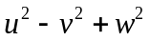, rank=3, Index=2, signature=1.
- Reduce the quadratic form to normal form through congruent transformations. Also find its rank, signature, index and value class. Ans: 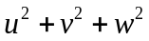, rank=3, Index=3, signature=3.

…………………………………………………………………………………..

